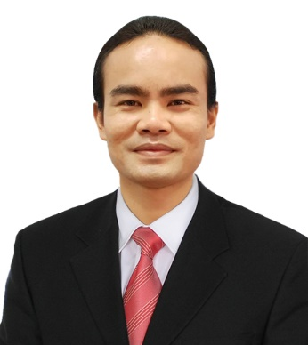
Namchok Petsaen
Founder and President of 4AllAble

Namchok Petsaen has been working as a freelance for web development for 5 years. During his time working as a freelance, he formed a small team to develop an online platform call “4AllAble” with the key concept for ACCESSIBLE, ENJOYABLE, AND INCLUSIVE FOR ALL. The 4AllAble platform is designed to be a unique online platform for person with disabilities (PWDs) providing information for accessible tourism/destination, job opportunity, education, sports, arts, news, events, market place for PWDs (equipment, product, services), and entertainment. This online platform is focusing on suitable and sustainable online business solution for PWDs as a long run business model and platform development process is divided into 6 parts (1. Accessible Tourism, 2. Online Market Place, 3. Sports & Entertainment, 4. Job Market & Opportunity, 5. Education, 6. Technology & Innovation). In 2019, some parts of accessible tourism will be available to all users at website 4AllAble.com

