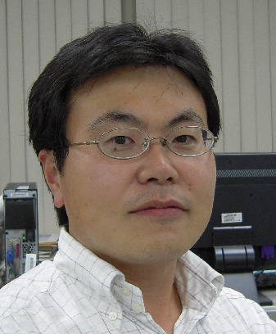

松原 稔
アセットマネジメント部責任投資グループ グループリーダー
1991年4月にりそな銀行入行、年金信託運用部配属。以降、投資開発室及び公的資金運用部、年金信託運用部、信託財産運用部、運用統括部で運用管理、企画を担当。2017年4月より現職。
2000年 年金資金運用研究センター客員研究員、2005年 年金総合研究センター客員研究員。
日本サステナブル投資フォーラム運営委員、PRI（国連責任投資原則）日本ネットワークコーポレートワーキンググループ議長、持続可能な社会の形成に向けた金融行動原則運用・証券・投資銀行業務ワーキンググループ共同座長兼運営委員。経済産業省「TCFD研究会」ワーキンググループ委員。経済産業省「ＥＳＧ投資を活用した産業保安に関する調査研究会」委員。日本証券アナリスト協会検定会員、日本ファイナンス学会会員

Minoru Matsubara
Chief Manager of Responsible Investment Group,
Asset Management Division at Resona Bank, Limited.

Mr. Matsubara has been Chief Manager at Responsible Investment Group, Asset Management Division, since April 2017. Prior to his current position, he was Group Lead at Trust Fund Management Division. Planning and Monitoring Group at Resona since April, 2009. He began his carrier at Daiwa Bank (current Resona Bank) in April 1991.
Mr. Matsubara’s membership role at government agencies includes Chairman of the Working Group of Principles for Financial Action for the 21st Century (PFA21) at Ministry of Environment (MOE), and TCFD Working Group member for Ministry of Economy, Trade and Industry (METI).
He is currently a member of ESG working group at MOE, Committee Member of Japan Sustainability Investment Forum (JSIF); Chairman of the Corporate Working Group of PRI Japan Network.
He is a chartered member of the Securities Analysts Association of Japan (SAAJ) He also used to be a Steering Committee for Investor Forum until July 2016. He is a member of the Nippon Finance Association.

